

**Brighton Centre**

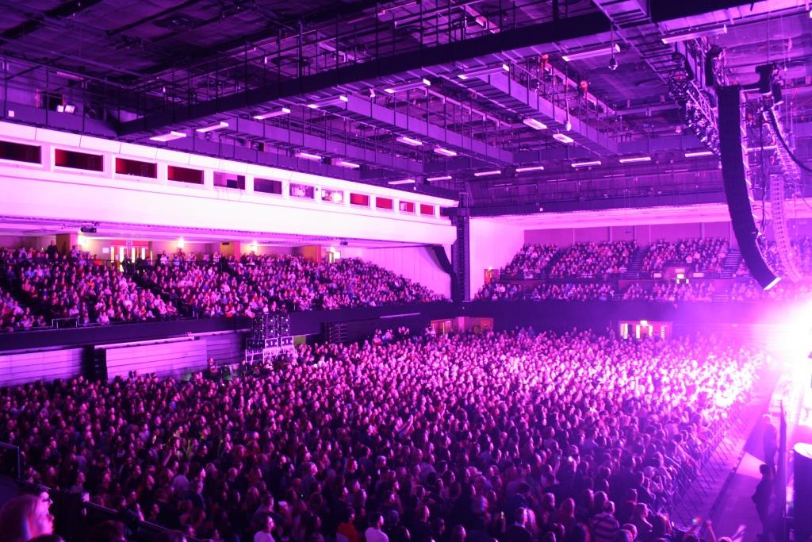**Access Statement**

**Contents PAGE**

**Introduction 4**

**Contact Us 5**

**Opening Times 6**

**Access Address Book 9**

**Booking Tickets and Accessible Areas 10**

**Access to Performance 16**

**Getting Here and Parking 17**

**Arriving at the venue 24**

**Early Entrance 28**

**Making your way around the venue 29**

**Accessible Toilets 32  
  
Changing Places Facility 33**

**Food and Drink 34**

**Merchandise 35**

**Assistance Dogs 35**

**Induction Loops 35**

**Sound levels 36**

**Strobe Lighting 36**

**Hidden Disabilities 36**

**Quiet Spaces 36**

**Customers with Medical Requirements 37**

**Medical Assistance 37  
  
Emergencies 38**

**Feedback 38**

**Additional information 38**

**APPENDIX I –**

**What is the ‘Access Address Book’? 39**

**APPENDIX II –**

**Access Requirement Form 42**

**Introduction**

The Brighton Centre is a multi-purpose venue in the centre of Brighton and is one of the largest purpose built event venues on the South Coast of England. We offer a warm welcome to everyone and aim to offer an excellent level of service to all our customers. We really want you to enjoy your time with us so if anything happens while you are at the Brighton Centre that makes you unhappy or concerned, please approach one of our staff and ask for the Duty Manager who will deal with your queries as best they can. All front-line staff have undertaken accessibility training and will do their best to ensure your visit is both enjoyable and safe.

The venue hosts a wide variety of events throughout the year including musical concerts of all genres, comedy shows, larger theatre productions, and public exhibitions. Full details of all forthcoming events are available on [the Brighton Centre website.](http://www.brightoncentre.co.uk/)

The main auditorium can hold a maximum of 4,270 for a seated event and up to 5,532 for a standing concert. There is a second, smaller auditorium in the Syndicate Wing (next door) which hosts occasional smaller concerts and is also used as part of the whole venue for some larger events.

The Brighton Centre offers:

* Accessible toilets
* A Changing Places facility
* Accessible lifts
* Box Office, Information Desk and bars with low level counters
* Box Office, Wristband Exchanges, Security and Information Desks with induction loops
* Staff who have undertaken accessibility awareness training
* Accessible viewing platforms
* Free ticket for a Companion (subject to evidence supplied)
* Dedicated Access Line for enquiries & booking accessible seating
* A Gold Award from “Attitude is Everything”

**Contact Us**

**General Enquiries:** 01273 290131

**Access Line:** 01273 292695

**Email:** [brightoncentre@brighton-hove.gov.uk](mailto:brightoncentre@brighton-hove.gov.uk)

**Web:** [www.brightoncentre.co.uk](http://www.brightoncentre.co.uk)

**Post:** Brighton Centre, Kings Road, Brighton, BN1 2GR

When emailing us with regards to a specific requirement please include the word ‘Access’ in the subject line so that we can prioritise your enquiry. We aim to respond to all access-related enquiries within 5 working days.

We are committed to equal opportunities. If you need this information in a larger font, or an alternative format, we will do all we reasonably can to help, please contact us for assistance.

This Access Statement is also available in Easy Read format. Please contact us for a copy or it is available to download from our website.

We welcome calls from customers using Relay UK.

All customer facing staff have undertaken disability awareness training.  
  
We have an Accessibility Officer at the Brighton Centre. For all Box Office enquiries please email or call Kat Jakubcova using the email address and telephone number above.

Kat is also contactable via post at the above address, just mark your letter for her attention.

**Opening Times**

We can arrange for you to come and visit the venue when there is nothing on if you think it would be helpful to familiarise yourself with the building before you attend an event at the Brighton Centre. Please contact us via your preferred method and we’ll be happy to assist you.

You can also watch a 360 Virtual Reality Tour video of the venue here: <https://www.youtube.com/watch?v=NNsPUAJKDPc> we made this with local charity Stay Up Late with the aim of being able to give more information to people who may be anxious about new experiences; the video includes our foyer, bars and auditorium empty before a show and then filling up with people.

Visit the link with a Virtual Reality headset if you have access to one to be fully immersed.

**Box Office**

The Box Office is open **Monday to Saturday 10am-4pm** and until the main act has gone on stage on event days. We are closed on Sundays and Bank Holidays unless there is an event on, when we will usually open from 4pm until the main act has gone on stage.  
  
On big on-sale days we aim to open the Box Office at the same time that tickets go on sale online - for example, if a show goes on sale at 9am on a Friday we aim to open then too.

The Box Office is available for over the counter bookings and also to answer the dedicated access telephone line, letters and email enquiries.

**Access Line and Email Enquiries**

The access telephone line is open to callers from **Monday to Saturday 10am-4pm** and until the main act has gone on stage on event days. The line is closed on Sundays and Bank Holidays unless there is an event on, when it will usually open from 4pm until the main act has gone on stage. Email enquiries are also answered during these times. If your enquiry is urgent and you’re sending us an email please mark it as such and include the word “Access” in the subject title.

When calling the Access Line if there is no answer please leave a voicemail message with a brief outline of your enquiry plus your telephone number, and we will call you back. Out of hours there is an answering machine facility so again, please do leave a message and we will get back to you.   
  
**Presales and On-Sales**  
  
On on-sale days we aim to open the Access Line for accessible bookings at the same time the show goes on sale (including during presales), therefore if a show goes on sale at 9am on a Friday we aim to be available from then too.   
  
During presales (including artist, album, venue etc.) if you are unable to purchase online due to your requirements we will be happy to assist you if you have signed up for presale access - such as having received a code, password or email - in these cases please call our Access Line and the team will be happy to assist.

During busy presales and on sales we use a call back system to ensure tickets are booked in the order in which customers contacted us, much like the online queuing system with Ticketmaster. We do not use a queue system for the Access Line as bookings often taken around 5 minutes per person and we feel leaving customers on hold for long periods of time isn't ideal. Therefore if there is no answer please leave a voicemail message with a brief outline of your enquiry plus your telephone number, and we will call all customers back in the order the messages are received.   
  
If you do not leave your telephone number in the message we cannot call you back. Please do not continue to call the Access Line once you have left a message and please only leave one message. If you do not leave a voicemail message but continue to ring the Access Line your call will not be answered until all messages have been called back.

**Event Days**

On event days Monday to Saturday the Box Office will open at 10am and on Sundays and Bank Holidays at 4pm, and close once the main act goes on stage.  
  
The approximate running times will be listed on the event’s dedicated page on our website and posted out via our social media channels, this will include the door opening times and curfew (when the building will close). You are welcome to call us to find out this information.   
  
As a general rule for shows, the doors usually open at 6:30pm and our curfew is 11pm. Matinee shows vary but the information will be available on our website. Please note that sometimes we do not get the running times until the day of the show and they are always subject to change.

We aim to have this information available as a recorded message on our telephone line too, dial 01273 290131 and select option 2 from the main menu.

Our Early Entrance Policy is available on **page 28**.

**Access Address Book**

We use an Access Address Book at the Brighton Centre as part of our continued efforts to develop the venues accessibility. This system has been designed to help our team better understand our customers’ needs and accommodate their requirements to ensure that the booking process is easier for you and more comprehensive for us.

Until we launched the Access Address Book we allocated accessible seating~~,~~ and free companion tickets~~,~~ via an honesty system; we did not ask for proof of eligibility, and subsequently the system was open to abuse. To prevent such misuse and to ensure these tickets are available only to customers with a legitimate need, we changed the way we manage these bookings.

Our system means that we can provide a greater number of tickets for our customers and identify areas of strength, or where we might need to improve. For those who require the aid of a free companion it means greater ticket availability and for those who visit us independently it will ensure that we find the best location possible to ensure they enjoy the event.

If you do require assistance when visiting the Brighton Centre, we offer free companion tickets. By registering eligibility for a free ticket, we can issue more tickets, however, it does mean evidence is now required to be eligible for a free companion ticket.   
  
If you’d like further information on our Access Address Book we’ve included a helpful guide on **pages 39 – 41** of this document, and the Access Requirement form on **pages 42 – 48**. Alternatively, they’re available to download from our website here:

[What is the Access Address Book? (word)](https://brightoncentre.co.uk/media/71476/access-address-book-faqs-may2023.doc)  
[What is the Access Address Book? (pdf)](https://brightoncentre.co.uk/media/71477/access-address-book-faqs-may2023.pdf)  
[Access Requirement Form (word)](https://brightoncentre.co.uk/media/71478/access-address-book-requirement-form-may2023.docx)  
[Access Requirement Form (pdf)](https://brightoncentre.co.uk/media/71479/access-address-book-requirement-form-may2023.pdf)

Or you can request them via email or post, our contact details are available on **page 5**.

**Booking tickets and accessible areas**

**Tickets**

Tickets for all events can be booked in several ways:

* **By phone:** call our access line on **01273 292695**, we welcome calls using Relay UK. This is a dedicated number for customers who have access requirements. The number connects directly with our Box Office staff who have an excellent knowledge of the venue and the layout of the seating. £1.50 Facility fee per ticket applies.
* **By email:** send your enquiries to [brightoncentre@brighton-hove.gov.uk](mailto:brightoncentre@brighton-hove.gov.uk). Please include the word ‘Access’ in the subject line of your email so we can prioritise your email and respond as soon as possible. If your enquiry is urgent please mark it as such. No booking fees apply.
* **In person:** at the Brighton Centre Box Office, located at the front of the venue on the seafront. £1.50 Facility fee per ticket applies.
* **By post:** you’re welcome to write to us but please be aware the process will be slower and we’d advise not doing so for a ‘popular’ show in case it sells out before we get your letter. Mark correspondence FAO Box Office Accessibility Officer, Brighton Centre, Kings Road, Brighton, BN1 2GR. Please do not send cash through the post, we’ll advise the best method for payment in our response.

Tickets booked via the Brighton Centre Box Office are available as E-tickets or as hard ticket stock; there is a postage and handling fee for tickets posted out.

Opening times for the above booking facilities are detailed above on **page 6.**

* **Online via Ticketmaster:** 24hr booking facilities are available online via Ticketmaster including accessible tickets. Booking and facility fees apply. If accessible tickets are not available online, please contact the venue as listed above. Booking fees and Facility fees apply.

[Information on all events can be found on the Brighton Centre website](http://www.brightoncentre.co.uk/) and bookings can be made via the dedicated event pages where you will be redirected to the Ticketmaster website; Facility Fee of £1.50 per ticket and booking fees will apply at 12.5% of the ticket price.

**Box Office**

The Box Office is on the ground floor at the front of the venue and is fully accessible. We have:

* A push-pad automatic door for exiting the box office
* Low level counter
* Induction loop
* Staff can provide information in large type on request, and can also arrange for information to be made available in alternative formats
* A magnifying glass is available
* Seating is available
* The floor surface is carpeted and level
* Staff who are trained in disability awareness

Box Office opening times are available on **page 6.**

**Brighton Centre Box Office entrance:**

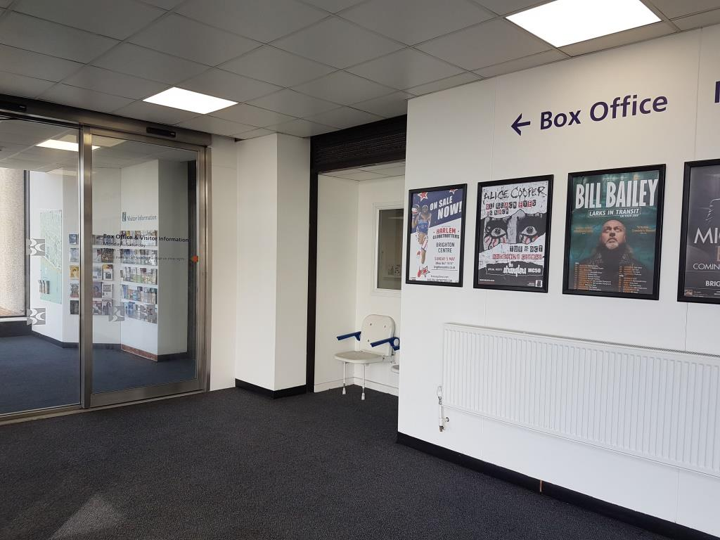

**Box Office low level counter:**

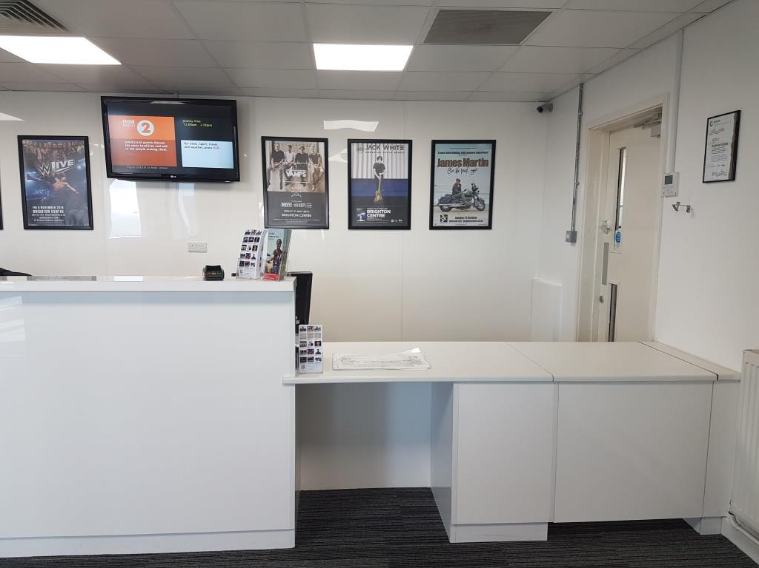

**Accessible Tickets and Companion Tickets**

For all accessible seating requirements please contact our Box Office so we can ensure that you receive guidance on our venue facilities and are able to book the best seats for your requirements. Please refer to the ‘Tickets’ section under ‘Booking Tickets and Accessible Areas’ on **page 10** for information on how to book. You may be asked to discuss your requirements with our staff directly when calling, but all information is treated with care and confidentiality.

We offer complimentary tickets for companions who are assisting Deaf and disabled customers in attending an event, this is an evidence based system and information is available under ‘Access Address Book’ on **page 9**.

Please note that Companion tickets are only available via the venue and online via Ticketmaster and not through any other ticket agents. We may not be able to refund Companion tickets if you do not let us know at the time of booking or if you have not booked via the correct channels.

Companions are expected to help with way-finding, assisting the customer into and out of the venue and auditorium, buying and carrying food and drink, and undertaking all access requirements of the person they are attending with. They are not expected to leave the customer alone for long periods of time, be unable to meet the customer’s access requirements, or be inebriated at the event.

**Accessible Areas**

If your access needs have changed since booking your tickets, please contact us and we’ll do everything we can to help you. This will be subject to ticket availability.

There are up to 12 spaces on the South Balcony’s accessible platforms which are raised. These areas are usually available on both seated and standing shows. The view from the platform is front facing and the area is stewarded. The area is accessible via both lift and stairs. The closest accessible toilet is **25 metres**.

**Accessible platform on the South Balcony showing view of the stage:**

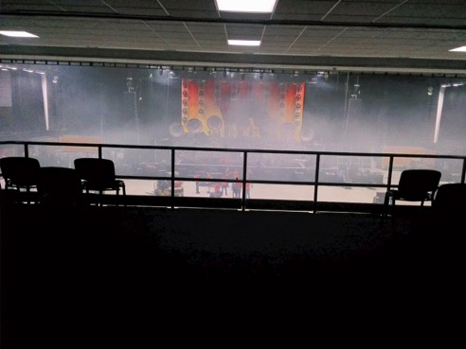

There are 8 spaces for wheelchair users available on the raised accessible platform for standing shows located in the South West corner of the standing area on the main floor of the auditorium. The platform is raised, front facing and is stewarded. For shows with stalls and standing area the platform is located on the West Wall of the auditorium and has a side facing view. It is accessed via both lift and stairs. The closest accessible toilet is **30 metres**.

**Accessible platform available at standing shows:**

Flat platform lift positioned at ground level with handles on both sides. Railing on the left side and the front of the platform. Platform has dark floor.


Tickets for the South Balcony accessible areas can be booked via the Brighton Centre Box Office and online via Ticketmaster. For other areas please contact the Brighton Centre Box Office. Please refer to the ‘Tickets’ section under ‘Booking Tickets and Accessible Areas’ on **page 10** for information on how to book.

For customers who don’t require seats on the accessible platforms but do have limited mobility we advise booking seats at the back of the South Balcony for standing shows wherever possible. Alternatively, on seated performances, the South or Flat Stalls have direct lift access however, please note that all areas, apart from the Flat Stalls, do have some steps to access them and are tiered seating.

If you have limited mobility we recommend that you do not book seats in the East and West Balconies or the lower rows (i.e. A – G) of the South Balcony as these areas are more difficult to access.

The Brighton Centre is a flexible venue and we’re here to help; we feel any part of our auditorium can be an accessible area if it works for you and your needs. We understand that everyone’s access-related requirements are different be it needing seats closer to the front, a quieter area, raised seating or front facing, so if you are unsure of what to book or for further advice and information please contact us; we’ll be happy to advise you on the different options available at the venue and book you into the best seats for you.

**Seating plans**

Please note that the following seating plans are given as a guide only and are not guaranteed for all events. Our Box Office staff will be able to help and explain the seating plan in use for any specific events.

**Seating plan for seated concerts:**

Stage, Flat Stalls, South Stalls, East Stalls and West Stalls on first floor.
East, West and South balconies on third floor.

Stage and standing area on first floor.
East, South and West balconies on third floor.**Seating plan for standing concerts:**

**Access to Performance**

The Brighton Centre is committed to offering access to performance services such as British Sign Language interpreters, Captioning and Audio Description and we are working very hard with concert promoters to provide these services if required.

We aim to provide access-upon-request to our customers who require an accessible provision to be put in place for them to be able to attend a performance, but this will be subject to the request being made within a reasonable timeframe (minimum 6 weeks before the event date) and approval from the event promoter. Please contact us if you require this service and we’ll do all we reasonably can to help.

We have the Sennheiser Mobile connect hearing loop connected in the venue, for more information see **page 35.**

**Getting Here and Parking**

The Brighton Centre is in the heart of the city on Brighton seafront. We’re easily accessible via public transport and are a short distance from Brighton Mainline Railway Station, Pool Valley Coach Station, city centre bus stops and taxi ranks; we also have our own cycle racks located at the front and rear of the venue. Our full address is Brighton Centre, Kings Road, Brighton, BN1 2GR.

**Parking**

If you are arriving by car, the nearest public car parks are Churchill Square Car Park 1 which gives very easy flat access to the rear doors of the venue, and to the Syndicate Wing, and Regency Square Car Park, which gives flat, level access along the seafront to the main doors at the front of the building however, there is a steep slope when exiting the car park. Please note that the car parks close to the venue can get very busy when shows finish and there may be a queue to exit.

**Churchill Square Car Park 1, BN1 2RU**

Full information on the car park, including parking charges, is available on [the Churchill Square website](https://www.churchillsquare.com/guest-services/#parking).

The entrance to the car park is via West Street. We advise customers to access this from the seafront road (Kings Road) as there is no right turn available if you are coming down West Street from the top of the road.

The height restriction of the car park is **2.13** metres.

Lighting in the car park is good.

There are accessible parking bays on all levels of the car park, but customers are advised to park on the lowest level if possible (Parking Level P1). If you park on a different level you will need to use the accessible lift to take you down to Parking Level P1 in order to exit the car park.

The distance from the car park exit to the venue is approx. **30 metres**. There is level access across the road with dropped kerbs via the pedestrian crossing next to the car park exit. Assistance is available via a call button if you need help when paying.

**Churchill Square car park exit:**

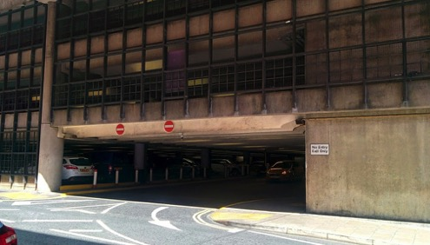

**Rear entrance to the Brighton Centre:**

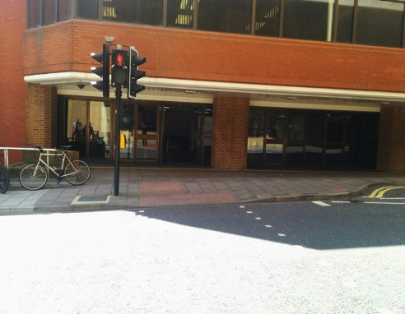

**Regency Square Car Park, BN1 2FG**

Full information on the car park, including a video and parking charges, is available from [the parking pages on the council's website.](http://www.brighton-hove.gov.uk/content/parking-and-travel/parking/regency-square-car-park)

This car park is a good option if you wish to access the Box Office and the main entrance to the venue, which are both on Kings Road, on the seafront.

The entrance to the car park is via Kings Road, opposite the old West Pier.

The height restriction of the car park is **2.13 metres**.

This is an underground car park. Customers are advised to park on the lowest level for ease of exit. Please note there is no lift in the car park and a steep slope when exiting the car park.

The distance from the car park to the venue is approx. **250 metres**. There is a short incline on leaving the car park but then the journey to the venue is flat and level with dropped kerbs at each junction along the seafront to the venue.

Assistance is available via a call button if you need help when paying.

Lighting in the car park is good.

**Regency Square Car Park interior:**

[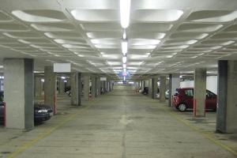](https://www.google.co.uk/url?sa=i&rct=j&q=&esrc=s&source=images&cd=&cad=rja&uact=8&ved=0CAcQjRw&url=https://www.brighton-hove.gov.uk/content/parking-and-travel/parking/london-road-car-park&ei=gBdSVe2kLMH_UojpgLAJ&bvm=bv.92885102,d.d24&psig=AFQjCNHdpUdgGCCFLkq4kFQkgHn2Aq1sng&ust=1431529)

**Regency Square Car Park exit:**

[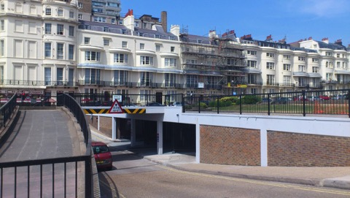](http://www.google.co.uk/url?sa=i&rct=j&q=&esrc=s&source=images&cd=&cad=rja&uact=8&ved=0CAcQjRw&url=http://www.wfc2013.org/travel01.html&ei=yhdSVfnKJML-UtbVgKAH&bvm=bv.92885102,d.d24&psig=AFQjCNHdpUdgGCCFLkq4kFQkgHn2Aq1sng&ust=1431529)

**Blue Badge parking and drop offs**

There are designated Blue Badge parking bays close to the venue in West Street and Cannon Place but please note that those in Cannon Place are on a hill going down to the seafront. Blue Badge holders can park free of charge and without any time limit in these bays.

There is a lay-by in front of the venue which has double yellow lines. This is ideal as a drop-off point and there is a dropped kerb available for easy access to the pavement at the far west side of the lay-by, where the Grand Hotel Crescent meets Kings Road.

**Lay-by in front of the Brighton Centre:**

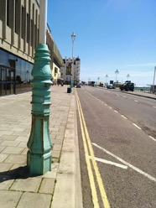

**Lay-by showing dropped kerb in front of the Brighton Centre:**

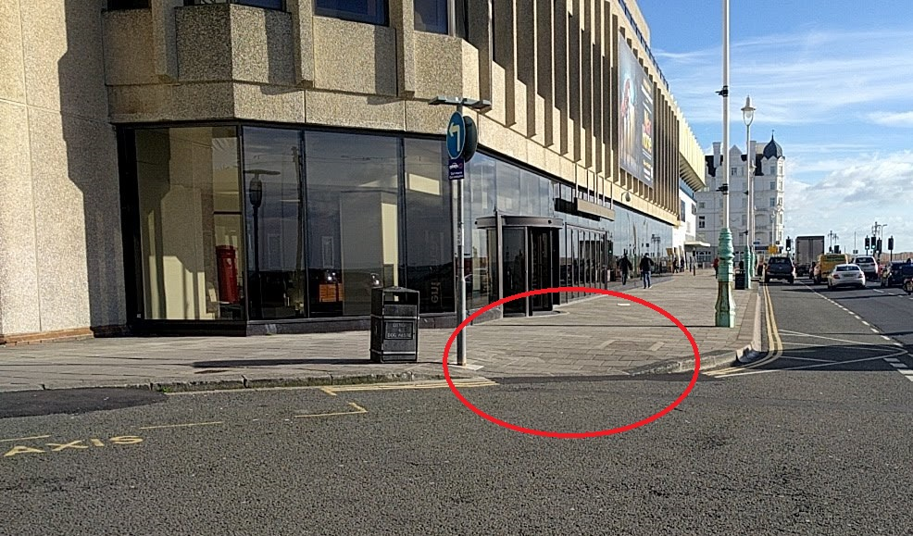

Blue Badge holders can also park in this lay-by for up to **3 hours** for most shows, if you set the clock on your badge and ensure this is clearly displayed. Please check with the venue beforehand as occasionally parking in this area is suspended, and some shows will be longer than 3 hours. Please also note that this area can become very congested, especially at the end of an event when everyone is leaving at the same time.

Blue Badge holders can also park for up to **3 hours** on any other single or double yellow line near the venue as per usual Blue Badge regulations, providing you are not on a corner or causing an obstruction, and as long as you set the arrival time on the clock on your Blue Badge.

**Taxis**

If you need to book an accessible taxi we recommend the following ~~taxi~~ firms, all of which have accessible taxis in their fleets:

**Brighton & Hove City Cabs:** Tel 01273 205205 [www.205205.com](http://www.205205.com)

**Brighton and Hove Radio Cabs:** Tel 01273 204060 [www.brightontaxis.com](http://www.brightontaxis.com)

**Brighton & Hove Streamline Taxis:** Tel 01273 202020 [www.202020taxis.cab](http://www.202020taxis.cab)

There are free taxi-phones that can be used to call a taxi inside the venue.

**Buses**

If you are coming to the venue by local bus, the nearest bus stops are outside Churchill Square shopping centre in Western Road. This is approx. **700 metres** from the rear entrance to the venue. Please note that access is via West Street which is on a hill. All city buses operated by Brighton & Hove Buses are accessible for wheelchair users. They also operate a “yellow card” scheme where you can alert the bus driver to any specific needs (e.g. please tell me when I get to my stop/please wait for me to sit down before you set off). More information is available on the [Brighton & Hove Buses website](http://www.buses.co.uk).

**Train**

If you are arriving by train you need to exit the station via the main exit at the front leading to Queens Road. From here there is step free access downhill to the seafront and the Brighton Centre. This is approx. **950 metres** from the rear entrance to the venue. There is also a taxi rank at the rear of the station. Please note that your return journey to the train station will be uphill.

**Photo Routes**

We have created eight step free photo routes from public transport hubs to the Brighton Centre. The photo routes show you the route to either Russell Road, the rear entrance of the Brighton Centre, or to Kings Road, the front entrance and the on-site Box office. Please click on the individual photo route links below.

[Brighton Station to Kings Road Entrance (Word doc.)](https://brightoncentre.co.uk/media/71430/access-route-brighton-station-to-kings-road-entrance.docx)

[Brighton Station to Kings Road Entrance (pdf.)](https://brightoncentre.co.uk/media/71432/access-route-brighton-station-to-kings-road-entrance.pdf)

[Brighton Station to Russell Road Entrance (Word doc.)](https://brightoncentre.co.uk/media/71433/access-route-brighton-station-to-russell-road-entrance.docx)

[Brighton Station to Russell Road Entrance (pdf.)](https://brightoncentre.co.uk/media/71434/access-route-brighton-station-to-russell-road-entrance.pdf)

[Churchill Square Bus Stop (South Side) to Kings Road Entrance (Word doc.)](https://brightoncentre.co.uk/media/71435/access-route-churchill-square-bus-stop-churchill-square-side-to-kings-road-entrance.docx)

[Churchill Square Bus Stop (South Side) to Kings Road Entrance (pdf.)](https://brightoncentre.co.uk/media/71436/access-route-churchill-square-bus-stop-churchill-square-side-to-kings-road-entrance.pdf)

[Churchill Square Bus Stop (South Side) to Russell Road Entrance (Word doc.)](https://brightoncentre.co.uk/media/71437/access-route-churchill-square-bus-stop-churchill-square-side-to-russell-road-entrance.docx)

[Churchill Square Bus Stop (South Side) to Russell Road Entrance (pdf.)](https://brightoncentre.co.uk/media/71438/access-route-churchill-square-bus-stop-churchill-square-side-to-russell-road-entrance.pdf)

[Churchill Square Bus Stop (North Side) to Kings Road Entrance (Word doc.)](https://brightoncentre.co.uk/media/71439/access-route-churchill-square-bus-stop-ms-side-to-kings-road-entrance.docx)

[Churchill Square Bus Stop (North Side) to Kings Road Entrance (pdf.)](https://brightoncentre.co.uk/media/71440/access-route-churchill-square-bus-stop-ms-side-to-kings-road-entrance.pdf)

[Churchill Square Bus Stop (North Side) to Russell Road Entrance (Word doc.)](https://brightoncentre.co.uk/media/71441/access-route-churchill-square-bus-stop-ms-side-to-russell-road-entrance.docx)

[Churchill Square Bus Stop (North Side) to Russell Road Entrance (pdf.)](https://brightoncentre.co.uk/media/71442/access-route-churchill-square-bus-stop-ms-side-to-russell-road-entrance.pdf)

[Clock Tower to Kings Road Entrance (Word doc.)](https://brightoncentre.co.uk/media/71443/access-route-clock-tower-to-kings-road-entrance.docx)

[Clock Tower to Kings Road Entrance (pdf.)](https://brightoncentre.co.uk/media/71444/access-route-clock-tower-to-kings-road-entrance.pdf)

[Clock Tower to Russell Road Entrance (Word doc.)](https://brightoncentre.co.uk/media/71445/access-route-clock-tower-to-russell-road-entrance.docx)

[Clock Tower to Russell Road Entrance (pdf.)](https://brightoncentre.co.uk/media/71446/access-route-clock-tower-to-russell-road-entrance.pdf)

**Shopmobility**

There is a Shopmobility service available in Brighton. The service is available from three locations: Churchill Square Car Park, Kemptown and London Road. Please call **01273 323239** for more information and to book. Normal opening times are **Monday to Friday, 10am to 4pm**. Winter times are subject to change. More information is available from [the Shopmobility website](http://www.thefedonline.org.uk/shopmobility).

**Arriving at the venue**

Information on opening times is available on **page 6** of this document; please note that show times are event specific.

When arriving at the Brighton Centre there are two entrances into the venue: on the seafront (Kings Road), and at the back of the building on Russell Road. Generally, both entrances are open but occasionally, depending on the event, it could be that only one entrance is available, in which case we will make sure that this is announced to our customers via our website and social media channels.

All entry doors into the venue are retained in the open position when events are taking place unless there are high winds on the seafront when they will be kept closed for safety reasons but manned by a member of staff. The clear door opening width of all entry doors is **1600mm**.

For the Box Office please use the front entrance, information on the accessibility of this space is available on **page 11** of this document.

The quietest entrance to the venue is at the back on Russell Road.

**Access via the front entrance – Kings Road**

There is step-free access via the front doors of the venue into the main foyer.

The floor surfaces are all smooth and level and the lighting levels are good.

**Main entrance to the venue and the Box Office:**

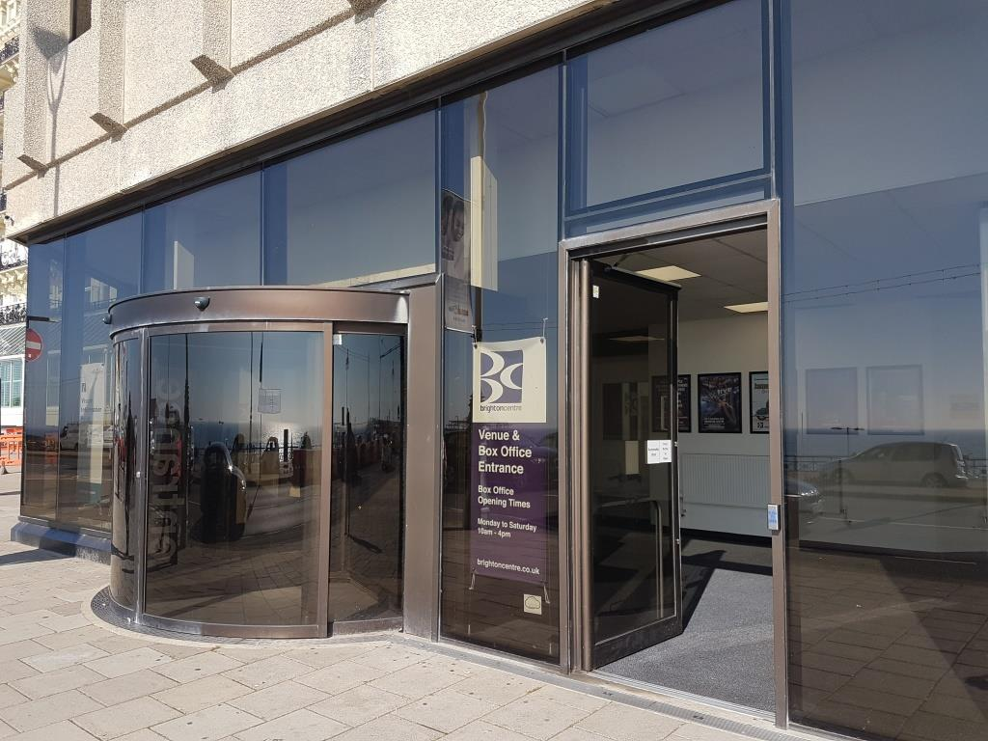

**Internal entrance leading to main foyer:**

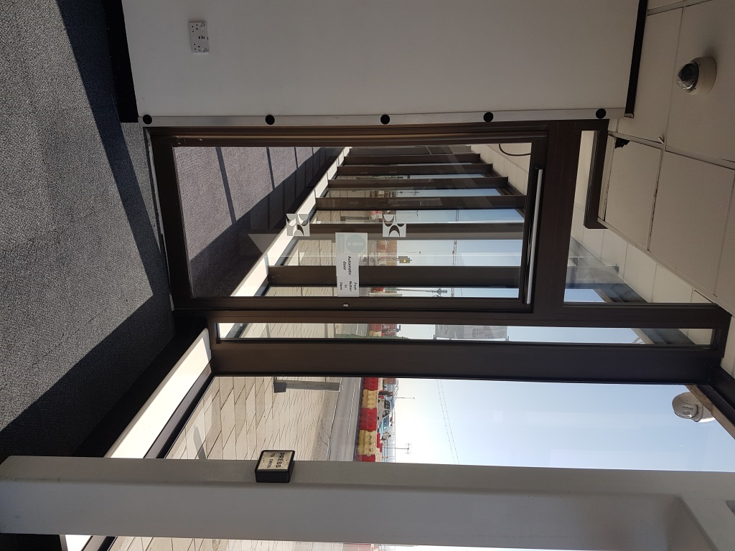

**Main foyer:**

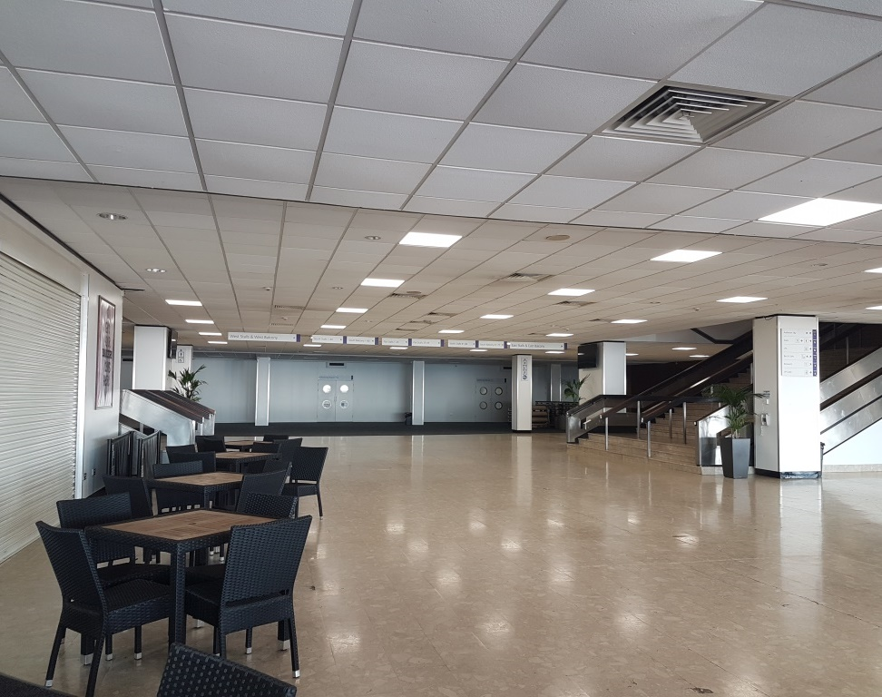

There are accessible lifts to take you to all floors of the venue from the main foyer.

**Access via the rear entrance – Russell Road**

Access via the Russell Road doors is step-free, and there is an accessible lift to take customers to the required floor.

The floor surface is level and carpeted, and the lighting levels are good.

**Rear foyer:**

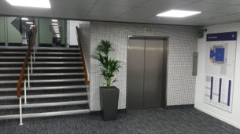

**Access to the Syndicate Wing – Russell Road**

Access is level to the doors of the Syndicate Wing and there is an accessible lift to take you to the first floor if required. Accessible toilets are also available on the ground floor.

The floor surface is level and carpeted, and the lighting levels are good.

**Syndicate Wing foyer:**

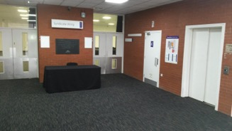

There is also a ramp which connects the main venue with the Syndicate Wing. The ratio of the ramp is **1:15**. The floor surface of the ramp is carpet, and the lighting levels at the ramp are good.

**Ramp access to the Syndicate Wing:**

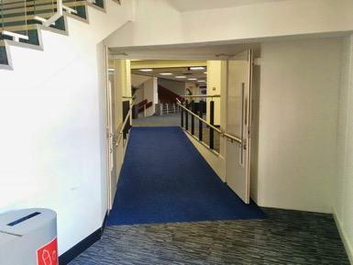

**Collecting Tickets**

If you have opted to collect your tickets rather than having them emailed to you, please come to the Box Office at the front of the venue. Information about the accessibility of the Box Office is available on **page 11** and opening times on **page 6**. When collecting tickets, we ask all our customers to provide us with their booking reference number and, where possible, the card used to make the booking.

**Once inside**

You’ll be greeted by security who will conduct a security search, and then stewarding staff who will direct you via the most accessible route to your seats; if you have any questions, please ask them for additional support or to show you where any facilities you require are. The accessible platforms are stewarded.

**Early Entrance**

If you need early access into the venue before the advertised door opening times, we will do all we possibly can to help and will arrange for seating to be made available if required. Although we are not able to offer early admission to the auditorium itself, we could arrange for you to access the outer foyer area, or the Russell Road entrance, so that you can avoid any long queues, especially for standing concerts.

Generally the entrance at the back of the venue on Russell Road is quieter than the main entrance at the front, and there is a lift available to take you to the first floor for the main auditorium and bars.

We can also arrange for you to come and visit the venue when there is nothing on if you think it would be helpful to familiarise yourself with the building before you attend an event.

Please contact us for advice.

You can also watch a 360 Virtual Reality Tour video of the venue here: <https://www.youtube.com/watch?v=NNsPUAJKDPc>

We made this with local charity *Stay Up Late* with the aim of being able to give more information to people who may be anxious about new experiences. The video includes our foyer, bars and auditorium empty before a show and then filling up with people.

Visit this link with a Virtual Reality headset if you have access to one to be fully immersed.

**Making your way around the venue**

If you have any problems, questions or require additional support please speak with a member of stewarding staff or security who will be happy to assist you and answer any questions.

We have created Access maps for the venue. These maps show location of facilities such as lifts, Accessible toilets and bars and cafes.

[You can download the maps as pdf here](https://brightoncentre.co.uk/media/71506/brighton-centre-access-map.pdf).

**Lifts:**

Whichever entrance you use there are accessible lifts to take you to the floor you need.

**Sizes of all lifts are:**

Door width – **1100mm**

Floor depth – **1700mm**

Floor width – **1950mm**

* All lifts have audible announcements for each floor level.
* The signage inside the lifts includes pictograms but is not tactile with Braille
* The buttons in the lifts are tactile with Braille
* There is currently no inductive coupler in the lifts.

**Lift entrance:**

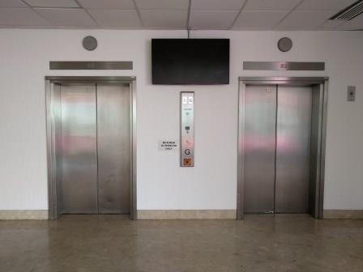

**Lift interior:**

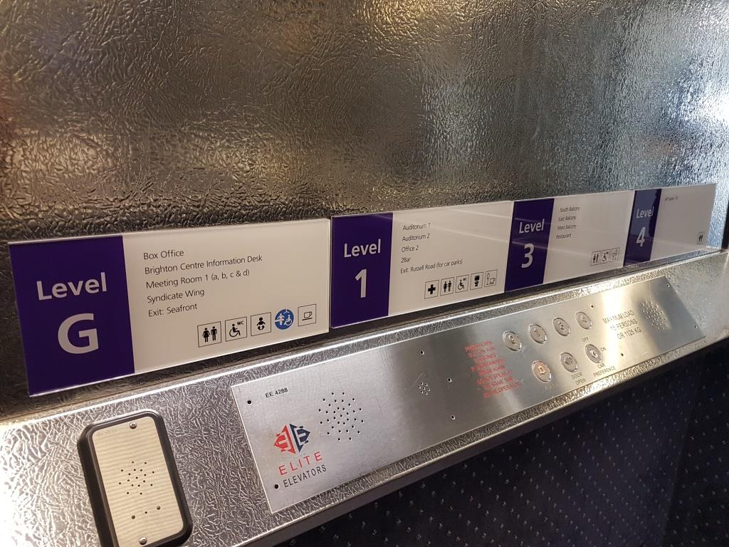

**Stairs**

There are also stairs to take you to all levels of the main venue which have handrails on both sides.

**Stairs from main foyer to 1st floor:**

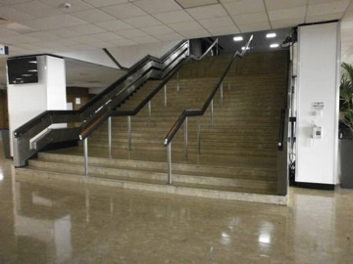

**Stairs from rear foyer to 1st floor:**

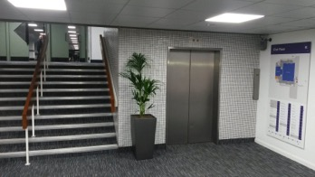

**Auditorium 1 & 2**

There is level access into both auditorium areas. Stewards will assist when required on the stairs to tiered seating in Auditorium 1. There are no stairs in Auditorium 2.

All floor surfaces are smooth and level.

**Syndicate Wing**

There is level access from the street into the Syndicate Wing, or there is an internal ramp which connects it to the main part of the venue. The ratio of the ramp is **1:15**.

**Ramp access to the Syndicate Wing:**

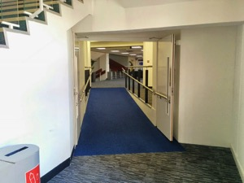

**Accessible Toilets**

There are accessible toilets on all floors in both the main venue and the Syndicate Wing.

* All toilets have level entry
* All floor surfaces are smooth and anti-slip
* All areas are well lit
* The door clear opening width to all the toilets is **760mm**
* The locks can be opened from outside in an emergency
* There is clear floor space in all the toilets up to **1200** x **1200mm**
* There is right and left hand transfer to the WC
* The space beside the WC is **800mm**
* Vertical rails are fitted beside the WC
* Most WC seats have lids
* The basin taps are lever taps
* Hot water temperature is controlled at the point of delivery
* There is a strobe light linked to the fire alarm
* There is an emergency cord
* There are colour contrasts between surfaces
* There is clear signage to all toilets
* There are baby changing facilities on the ground floor
* There are accessible toilets close to all accessible platforms

**Accessible toilet:**

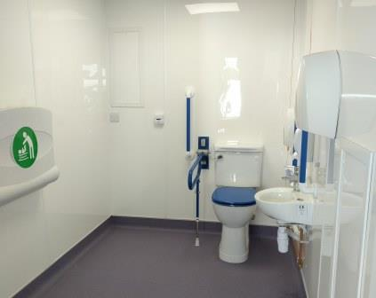

**Changing Places Facility**

* This facility has level entry
* The floor surface is smooth and anti-slip
* All areas are even and well lit
* Extra wide outward opening door with mid rail
* The lock can be opened from outside in an emergency
* There is clear floor turning space up to **1800 x 2000mm**
* There is left and right hand transfer to the WC
* Horizontal and vertical rails are fitted beside the WC
* Mechanical bidet toilet with rail kit
* Electric rise and fall hand basin with water sensor
* Hot water temperature is controlled before the point of delivery
* There is a strobe light linked to the fire alarm
* Two emergency pull cords with internal and external reset
* There are colour contrasts between surfaces
* Rise and Fall Barella Shower Trolley
* Max patient weight is: **150kg | SWL: 170kg**

**Changing Places Facility:**

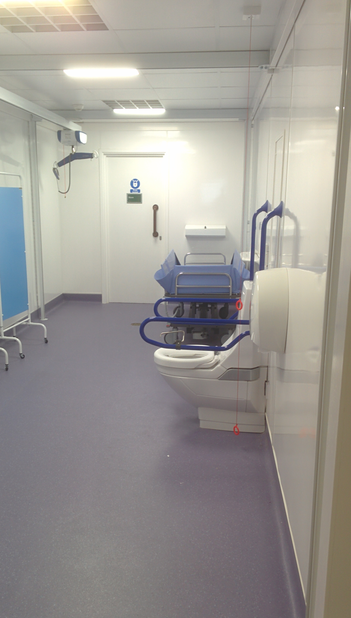Sink on the left wall.


**PLEASE NOTE THE FOLLOWING:**

Loop slings must be used with the two point spreader bar. We do not supply a harness sling. You must supply a sling to work with ‘*ARJO HuntleighV5 Duo Lift’*

Instructions are clearly displayed inside the toilet, and available from the Box Office and Information Desk, by entering the toilet you agree to the terms of use.

**Food and Drink**

There are two main bars available at most events. These are located on the East and West concourses that run alongside Auditorium 1; there are also cafés on these concourses. There is a café area available on the ground floor next to the Box Office, which is open at most events.

* All food and drink areas have level access
* The clear opening door width to the café is **1600mm** and the minimum clear space opposite the doors is **2500mm**
* There is space between the furniture and clear space under the tables is **680mm**
* There are low level counters at the bars
* Tableware contrasts with the tables
* All bar and café prices are available in large font on request
* Dietary needs can be catered for, please contact us if you have a specific requirement
* All areas are well lit, and the floors are level and anti-slip
* There are accessible toilets close to all the food and drink areas
* Hot food and hot drinks are not permitted in the auditorium

No cans, bottles, alcohol or food will be allowed into the venue and only food and drink purchased on the premises may be consumed in the venue. Should you require items due to a medical requirement please see information on **page 38** of this document.

**Low level counter at bar:**

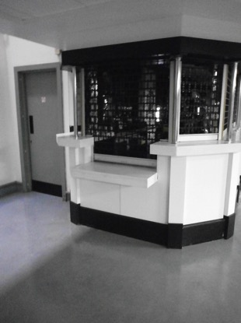

**Merchandise**

There is a merchandise stand located in the front foyer of the venue on the ground floor. The staff are available to offer additional support if required. A lowered counter is available on the right hand side of the stand. Large print price list is available from the staff.

**Assistance Dogs**

Brighton Centre welcomes assistance dogs. They can either accompany you to your seat, or venue staff will willingly look after your dog while you enjoy the event. We can provide water bowls for your dog if required. There is a designated spending area on the Ground Floor near the cloakroom through a set of fire doors into an outside area that is not able to be accessed by the public, please ask the Information Desk Staff to show you were the area is. Alternatively, waste bags can be disposed of in bins outside the front entrance on the seafront and at the back on Russell Road.

**Induction Loops**

We have the Sennheiser Mobile Connect hearing loop system connected in the venue. It is an assistive and personal listening solution that streams live audio content via WiFi to any iOS or Android phone in the room.

To use the system, simply download the Sennheiser app via Google Play or the App store app (it is good to do this in advance of the visit) or scan a QR code on site. Once customers have the app on their device, they are ready to go, no passwords or login are required. At the venue, connect to the Brighton Centre wi-fi network, enable Bluetooth and link to the hearing aid. Once on the app, tap 'Auditorium 1' and press play. The app has adjustable volume.

There are induction loops available in the Box Office, on our Information Desk, at wristband exchange points and at our Security Desk. Hearing aids need to be switched to the T position to receive the signal.

**Sound Levels**

We have little influence in the running of live music events when it comes to sound levels. Artists generally travel with their own sound and lighting systems and their engineers control them throughout the event. We do monitor both sound quality and decibel output and we will advise production crews when necessary, although we will not be able to turn the volume down unless it is breaching legal limits. Ear plugs are available on request from a member of staff.

**Strobe Lighting**

Please also be aware that some shows will contain strobe lighting or smoke effects. Signage will be available in the venue to advise customers of this. Please contact us before booking tickets if this is an issue for you, and we will contact the promoter on your behalf to check.

**Hidden Disabilities**

The Brighton Centre understands that not all disabilities are visible and therefore, we recognise the Sunflower Lanyard scheme, and our staff are briefed to understand and support where necessary if a customer is wearing one. If you would like to contact us in advance to discuss your requirements or for additional information please do get in touch and we’ll be happy to assist you.

**Quieter Spaces & Respite Space**

The Brighton Centre is a compact venue and therefore does get very busy however, some areas are quieter than others on show nights.

Entering via the back of the venue on Russell Road is the quietest option and usually has little to no queues.

Of the main bars the West Bar is generally more quiet and seating is available. The venue medical room is also located off the West Bar and can be used as a quiet space.

If you are feeling uncomfortable or would like to be shown to a quiet space, please ask a member of stewarding staff or security who will be happy to assist you. We have a Respite Space available for anyone who needs to take some time away from the performance. It is located on the ground floor next to the cloakroom and close to facilities including toilets, the information desk and a water fountain.

The room has low lighting, comfortable furniture and blankets available.

**Customers with Medical Requirements**

We welcome attendees who need to bring medicines, food or drink to manage a medical condition. You are welcome to contact us in advance of your visit for advice, prior written acknowledgement from the venue of your requirement, or should you have any concerns or questions; you are also welcome to bring any supporting documents to the venue with you should you wish.

Our door staff are trained in our venue policy regarding understanding our policy for customers with medical requirements and understand that people may need to supply their own provisions to self-manage their condition. If a member of door staff has any questions they will call a Duty Manager to discuss the matter in private.

­

**Medical Assistance**

Trained First Aiders are available for all events and can be summoned by stewards. There is also a First Aid Room available at all events, which can also be used as a quiet space if the Respite Space is not appropriate for the situation.

**Emergencies**

In the event of an emergency there will be both an audible alarm in all areas, as well as flashing lights in the main auditorium and strobe lights in the accessible toilets. Stewards will ensure the safe exit of all people.

There are Evacuation Chairs available. These have a safe working load of **136kgs**, and staff are trained to use them.

All areas of the venue have emergency evacuation plans including the accessible areas. Our staff are fully trained in the evacuation of the venue and each accessible area has a specially trained member of staff who can evacuate people from the accessible areas.

If you would like further information on the plan for the area, please do not hesitate to contact us in advance or speak to a member of our stewarding staff when you arrive at the venue.

**Feedback**

We welcome feedback on how we can improve the experience for all visitors. Please contact us to let us know what we can do to improve both this Access Statement and your experience of the venue in general.

**Additional Information**

General information about the city including places to stay, things to do and what’s on is available from [the VisitBrighton website.](http://www.visitbrighton.com/) There is a dedicated section on accessibility where you can find information on accessible accommodation and things to do.

Care has been taken to ensure that the information in this Access Statement was correct at the time of publication. If you need any reassurance about any aspect of the venue’s accessibility, please contact us.

**Published:** August 2023

**Review Date:** August 2024

**Appendix I – What is the ‘Access Address Book’?**  
  
**Introduction**

As part of our continued efforts to develop the venues accessibility we use an ‘Access Address Book’; a document for the exclusive use of our Box Office team to assist with accommodating specific access requirements and the requests of our Deaf and disabled customers.

This system has been designed to help our team better understand our customer’s needs and accommodate their requirements to ensure that the booking process is easier for you and more comprehensive for us.

We believe that by maintaining a list of our customers and their requirements we can better understand the barriers they may encounter when visiting the Brighton Centre and limit any potential impact. In short, this system helps us provide the best service possible by tailoring our events to your needs.

**What is the ‘Access Address Book’?**

The ‘Access Address Book’ is essentially a list which will detail customer’s essential contact information in addition to any details which may help our Box Office team when booking for an event at the Brighton Centre. It will detail your specific requirements in addition to any personal preferences you may have. For example, if you have visited before, you might favour a particular area of the auditorium and the list will notify us of this so when you book, we’ll know.

**Why do you need this information?**

Until we launched the Access Address Book we allocated accessible seating and free companion tickets via an honesty system, we did not ask for proof of eligibility, and subsequently the system was open to abuse.

In order to prevent misuse and to ensure these tickets are available only to customers with a legitimate need, we decided to change the way we manage these bookings.

The Brighton Centre works closely with ‘Attitude is Everything’ to improve the service we provide to our Deaf and disabled customers and as part of our commitment we want to ensure that our resources are to the highest standard and available to as many people as possible.

The implementation of this system means that we are now able to provide a greater number of tickets for our customers and identify areas of strength, and where we might need to improve.

For those who require the aid of a companion it means greater ticket availability and for those who visit us independently it will ensure that we find the best location possible to ensure they enjoy the event.

**I need to bring a companion. How does that work?**

Some people require assistance when visiting the Brighton Centre and we do offer free Personal Assistant tickets in such cases. By registering eligibility for a free ticket, we can issue more tickets than our previous system where the amount was capped per event.

To issue free Companion tickets we need proof of eligibility by one of the means listed below:

• Front page of DLA / PIP letter (no specific rate required)

• Front page of Attendance Allowance letter (no specific rate required)

• Evidence that registered severely sight impaired (blind)

• Recognised Assistance Dog ID card

• Letter from 24hr Care Home (please contact the Box Office)

• Recognised Access Card with a +1 symbol (such as CredAbility)

(Please feel free to blackout any information that relates to amount of benefit paid or health conditions etc. that might be on any documents submitted)

If you do not have any of the above evidence but wish to apply for a free ticket for a Companion, please complete the Access Requirement Form, Section 3.2. You are welcome to post or email copies of any additional evidence that supports your application if you have any or contact us to discuss your application. Applications are assessed on a case-by-case basis.

**What do I need to do now?**

Complete the Access Requirement Form below, the answers provided will be added to our secure ‘Access Address Book’ and used to assist our Box Office team in finding you the most suitable ticket for your chosen events.

The form can be completed by either the person with the disability or by the companion. Please then send the form back to us at -

Brighton Centre Box Office, Brighton Centre, Kings Road, Brighton, BN1 2GR

or email it to us at [BrightonCentre@brighton-hove.gov.uk](mailto:BrightonCentre@brighton-hove.gov.uk) .

Once we receive the completed form, we will contact you using your preferred method to finalise and confirm the details you have provided.

**Is my information secure?**

Yes. The Brighton Centre holds personal and access information about our customers ~~to~~ provide the best possible service to you. We will always ask for your consent to hold your details and we will never share any details held on the Access Address Book. For further information on how we handle your personal data please visit <https://brightoncentre.co.uk/privacy-policy>

**What happens next time I want to book something?**

Once you’ve completed and returned the form we’ll have your details so when you next book please tell us you’re on the Access Address Book and we’ll do the rest.

**Appendix II – Access Requirement Form**

This form can be made available in alternative formats.   
Please ask a member of staff, email   
[BrightonCentre@brighton-hove.gov.uk](mailto:BrightonCentre@brighton-hove.gov.uk) or call us on   
**01273 292695** for further information

**Part 1: Personal Details**Name:   
Address:   
Postcode:  
Tel / Mobile:   
Email:   
Booking Reference Number:

**Part 2: Access Provision Requirement**

**Please check the box next to the access provisions you require:**

|  |  |  |  |
| --- | --- | --- | --- |
| Wheelchair User Space |  | Wheelchair dimensions (in mm)  Width of wheelchair:  Length of wheelchair: | |
| No steps |  | Front facing seat |  |
| Minimal steps |  | Induction loop |  |
| Seat close to toilets |  | BSL Interpreter |  |
| Seat close to exit |  | Assisted Performance: BSL Interpreted |  |
| Aisle seat |  | Assisted Performance: Captioned |  |
| Seat close to stage |  | Assisted Performance: Audio Described |  |
| Will you be bringing a companion: YES / NO | | | |

**2.1. Additional Requirements**If you have requirements not covered by the options above or would like to give us further information please provide details bellow (attach extra pages if required):

**2.2. Preferred Location**

If you have attended events at the Brighton Centre in the past and have a preferred location please provide details below (attach extra pages if required):

**Part 3: Information / Evidence**

Evidence is required to gain a free companion ticket.

If you do not require a Companion ticket but would like to be on our Access Address Book please leave this section blank.

**3.1. Eligibility**

To be eligible we require a photocopy or scan of one of the following documents (dated within the past 12 months if DLA or Attendance Allowance). Please check the box next to the evidence you wish to submit:

Front page of DLA / PIP (no specific rate required)

Front page of Attendance Allowance letter (no specific rate required)

Evidence that registered severely sight impaired (Blind)

Recognised Assistance Dog ID card (or similar provision)

Letter from 24hr Care Home (Please contact the Box Office)

Recognised Access Card with a +1 symbol (such as the Nimbus Access Card)

None of the above (see below)

Please note we are unable to accept a Blue Badge as evidence

You are welcome to post or email copies of any additional evidence that supports your application, or contact us to discuss your requirements. All applications for free personal assistant tickets will be assessed on a case-by-case basis.

**3.2. Statement (with option to send alternative evidence)**

We recognise that the evidence above is not definitive. If you do not have any of the above evidence but wish to apply for the above access facilities, use the box below to state why you require them (please use extra pages if required):

You are welcome to post or email copies of any additional evidence that supports your application if you have any, or contact us to discuss your requirements. All applications for free companion tickets will be assessed on a case-by-case basis.  
  
 **Part 4: Data Protection**

Prior to ticking the below boxes please take time to read our Privacy Notice for signing up to and being on our Access Address Book which we have included on page 5 of this form so that you have full information about how we use your data prior to offering consent. **We will not share your data with any third party organisations.**

We would like to retain data for your convenience, so that you do not need to re-submit this form every time you wish to book with us.   
Once we’ve received your form we can hold your data for a period of 3 years with your consent. We will contact you after 3 years of being on our Access Address Book to ensure you wish to remain on the system and check that the details we are holding are correct. You can then contact us to rebook access facilities without having to submit a form and evidence. If you would be happy for us to retain the data submitted with this form, please tick this box:

As part of the Brighton Centre’s continued efforts to improve access to our venue we would like to contact you on occasion for marketing purposes, customer satisfaction surveys. Please tick the box if you are happy for us to do so.

We would also like to be able to contact our Deaf and disabled customers with ideas and thoughts about improvements to access facilities at the Brighton Centre. Please tick this box if you’d be happy for us to do so.

We send a monthly Access Newsletter including information on upcoming shows and accessible performances. Please tick this box if you’d be happy for us to send this to you via email.

**Preferred method of contact**

Please use the boxes below to indicate your preferred method of contact, if you have more than one preference please number your choices 1-3 (1 being most preferred and 3 least preferred)

Email  Phone  Post

Once we’ve received your completed form we’ll contact you to finalise your booking if one has been made.

**Part 5: Submitting your Form**

You can submit your completed form and supporting documentation in the following ways:

**Email** your completed from to: [BrightonCentre@brighton-hove.gov.uk](mailto:BrightonCentre@brighton-hove.gov.uk)   
Or, **post** your completed form to:

Brighton Centre Box Office

Brighton Centre

Kings Road

Brighton

BN1 2GR

If you need help completing your form, would like to visit the venue to view the available facilities or have any questions about this process please contact us by emailing [BrightonCentre@brighton-hove.gov.uk](mailto:BrightonCentre@brighton-hove.gov.uk) or call us on 01273 292695 (open Monday – Saturday 10am – 4pm).  
  
**Submitting supporting documents**

When submitting documents to support your form, we ask that if possible you:

* Scan evidence and attach it with your form if emailing
* Photocopy evidence and clip it to a printed form if posting

This helps to speed up the process considerably.

Please feel free to black-out any information that relates to amount of benefit paid or health conditions etc. that might be on any documents submitted.

**Privacy Notice**

Our Access Address Book allows us to hold information about your access requirements and as to whether or not you are eligible for a free companion ticket, this information is considered Sensitive Data. We hold this information so that we are better able to understand your requirements, book tickets in the most suitable location within the auditorium for you, and we do not have to ask you questions about your access requirements every time you make a booking with us.

* **What information is being collected:** Name, Contact Details [telephone number, email address and postal address], Access Requirement
* **Legal Basis for Processing:** Performance of a Contract & Explicit Consent
* **Who is collecting it:** The Brighton Centre
* **How is it collected:** directly from the customer
* **Why is it being collected:** to offer faster and simpler booking processes for our Deaf and disabled customers
* **How will it be used:** for quick reference by our Box Office team to ensure they are booking the right ticket for a customer’s specific access requirements and to confirm as to whether a customer requires a free companion ticket
* **Who will it be shared with:** no-one
* **How long we will keep it for:** 3 years, after 3 years we will contact you to ask if you want to remain on our address book and if the information we hold is still correct

When signing up to the Access Address Book you also have options to consent to receive marketing communications from us, to take part in satisfaction surveys and offer your thoughts and feedback on new access projects we are undertaking. If you consent to any of these communications they will come directly from us and we will not use a third party Data Processor without contacting you for further consent.

**Important:** any evidence or documents submitted to confirm requirement for a free companion ticket are destroyed once reviewed, marked as “seen” on the Access Address Book and not kept by us.

For further information and to read our Privacy Policy please visit: <https://brightoncentre.co.uk/privacy-policy>

Last updated: 24 May 2018