**Churchill Square bus stops (shopping centre side) 🡪 Russell Road – rear entrance of the Brighton Centre**

**Distance 0.3 mile, approx. 5 minutes**

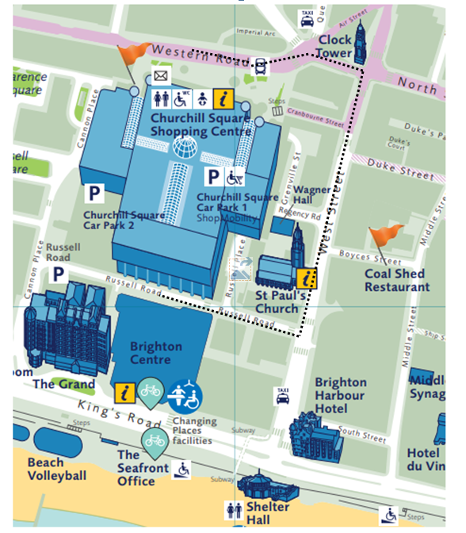

|  |
| --- |
| **Follow the path, with the Churchill Square shopping centre to your right.** |
|  |
|  |
|  |
| **Continue straight ahead past Metro Bank.** |
|  |
|  |
|  |
| **At the corner of Waterstones, turn right onto West Street.** |
|  |
| **Continue down West Street.** |
|  |
|  |
| **Take care when crossing towards Wetherspoons, this is an entrance to Churchill Square car park.** |
|  |

|  |
| --- |
| **Continue down West Street.** |
|  |
| **Turn right onto Russell Road.** |
|  |

|  |
| --- |
| **Continue along Russell Road towards the traffic lights.** |
|  |
|  |
|  |

|  |
| --- |
| **At the traffic lights cross over towards the rear entrance of the Brighton Centre.** |
|  |