Churchill Square bus stops (shopping centre side) to Kings Road – front entrance of the Brighton Centre

Distance 0.3 mile, approx. 6 minutes
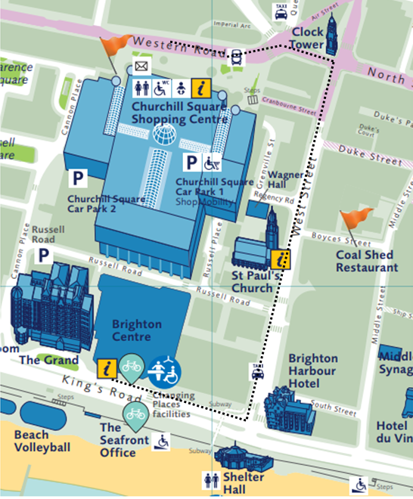

Follow the path with the Churchill Square shopping centre to your right.

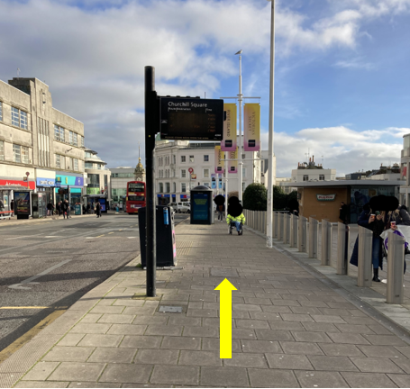
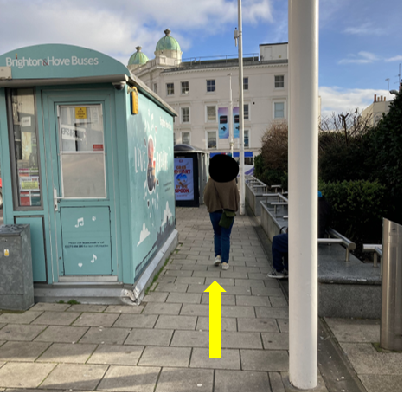
Continue straight ahead past Metro Bank.

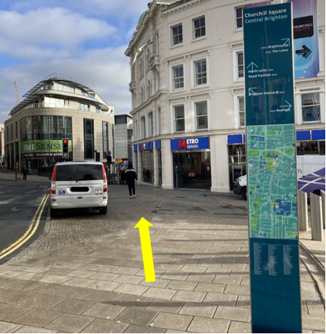
At the corner of Waterstones, turn right onto West Street.

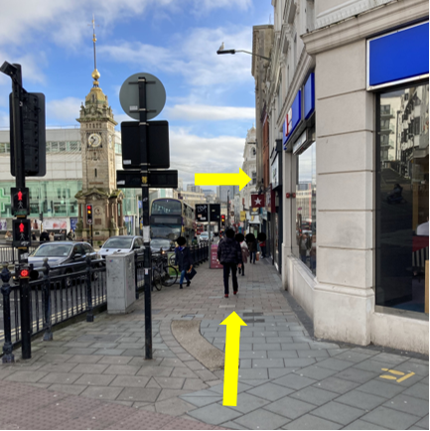
Continue down West Street.

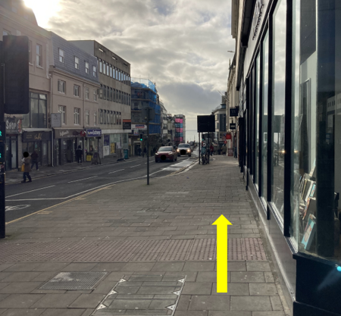

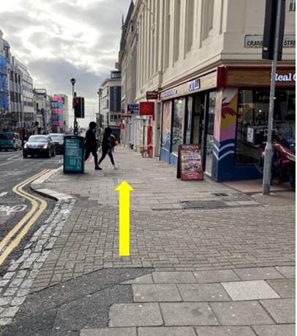
Take care when crossing towards Wetherspoons, this is an entrance to Churchill Square car park.

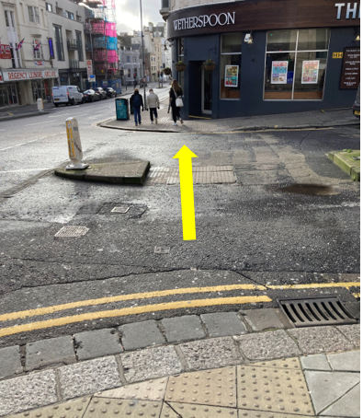

Continue down West Street.

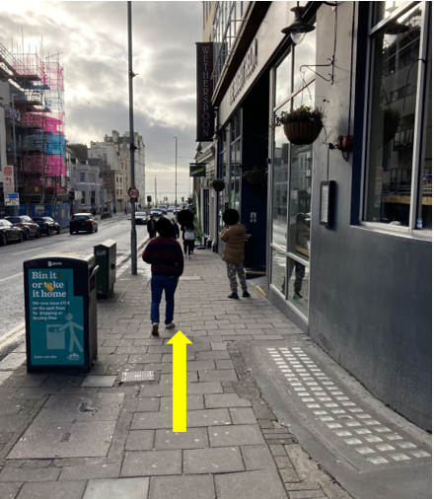
Continue down West Street.

Cross over at the traffic lights and continue straight ahead towards the sea.

At the bottom of West Street, turn right onto Kings Road.

Follow the path towards the Brighton Centre.

Continue along the front of the Brighton Centre.

Front entrance to the Brighton Centre.

