Clock Tower to Russell Road – the rear entrance of the Brighton Centre

Distance 0.2 mile, approx. 4 minutes
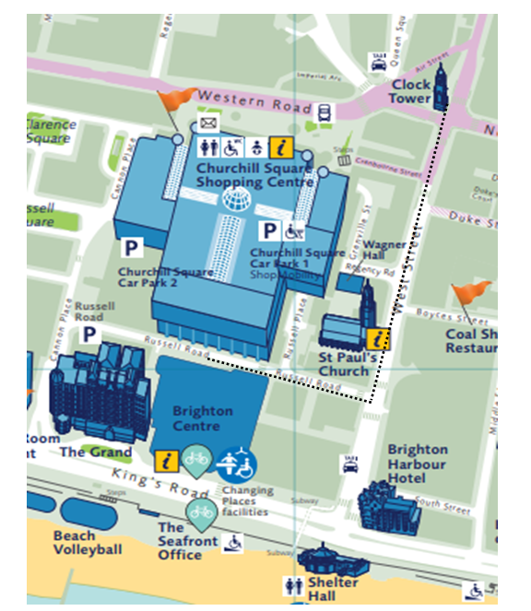
From the Clock Tower head towards Waterstones.

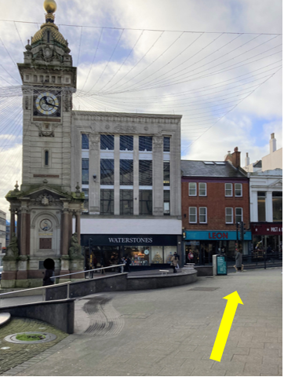

Cross over at the traffic lights towards Waterstones.

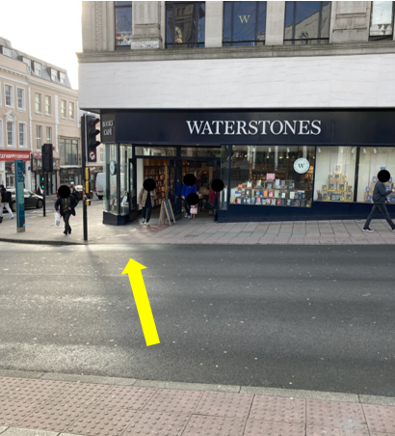
At the corner of Waterstones continue down West Street.

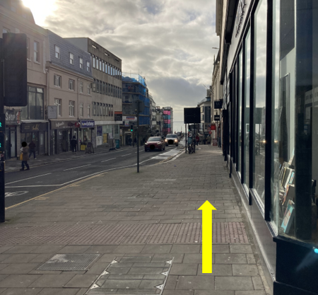

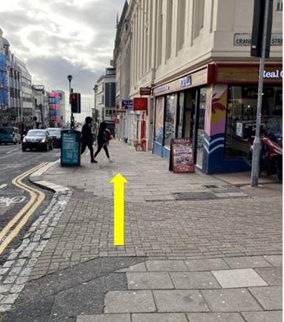
Take care when crossing towards Wetherspoons, this is an entrance to Churchill Square car park.

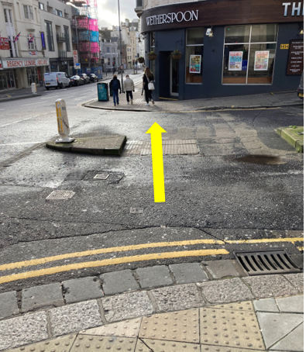

Continue down West Street.

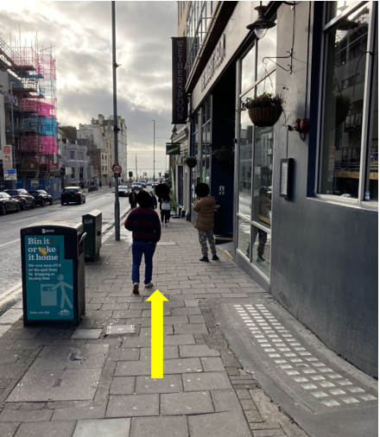
Turn right onto Russell Road.

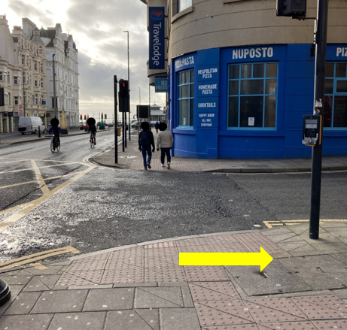

Continue along Russell Road towards the traffic lights.

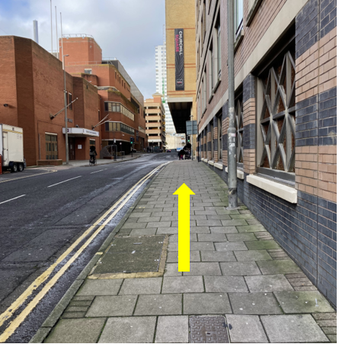
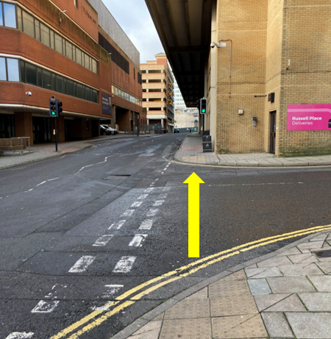

At the traffic lights cross over towards the rear entrance of the Brighton Centre.

