**Brighton Station to Russell Road – the rear entrance of the Brighton Centre**

**Distance 0.6 mile, approx. 11 minutes**

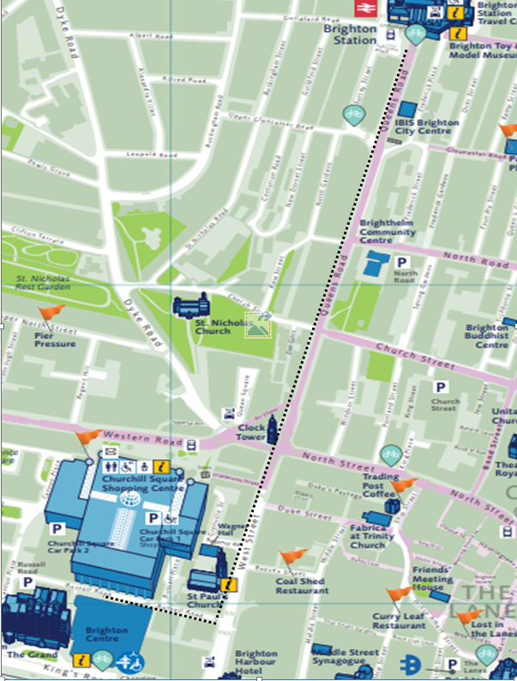

|  |
| --- |
| **Exit the station via the front entrance.** |
|  |
| **Cross over at the traffic lights onto Queens Road.** |
|  |

|  |
| --- |
| **Continue straight ahead along Queens Road.** |
|  |
| **Cross over at the traffic lights and continue straight ahead.** |
|  |
|  |
|  |
|  |
|  |

|  |
| --- |
|  |
|  |
|  |
|  |

|  |
| --- |
|  |
|  |
|  |
|  |

|  |
| --- |
| **Continue towards the Clocktower.** |
|  |
| **Follow the walkway towards Waterstones.** |
|  |

|  |
| --- |
| **Cross over at the traffic lights towards Waterstones.** |
|  |
| **At the corner of Waterstones continue down West Street.** |
|  |

|  |
| --- |
|  |
| **Take care when crossing towards Wetherspoons, this is an entrance to Churchill Square car park.** |
|  |

|  |
| --- |
| **Continue down West Street.** |
|  |
| **Turn right onto Russell Road.** |
|  |

|  |
| --- |
| **Continue along Russell Road towards the traffic lights.** |
|  |
|  |
|  |

|  |
| --- |
| **At the traffic lights cross over towards the rear entrance of the Brighton Centre.** |
|  |