Churchill Square bus stop (M&S side) to Russell Road – rear entrance of the Brighton Centre

Distance 0.3 miles, approx. 6 minutes
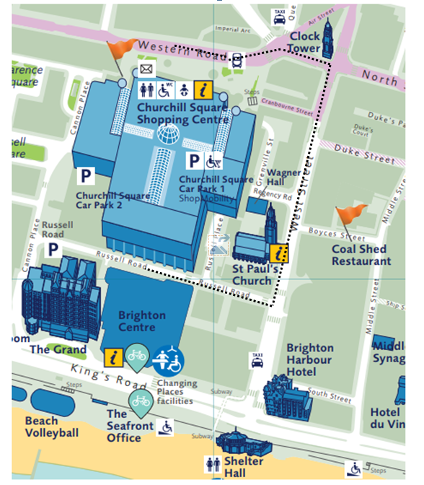

From the bus stops on Western Road, outside or near the Marks & Spencer store, with the store to your left, go straight ahead towards a set of traffic lights.

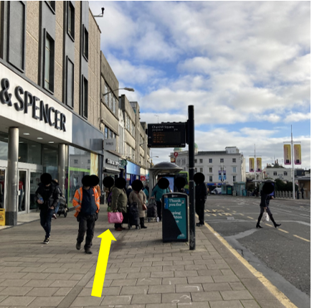
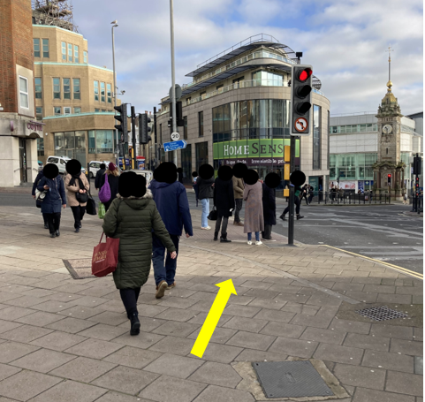

At the traffic lights, cross over towards the Metro Bank.

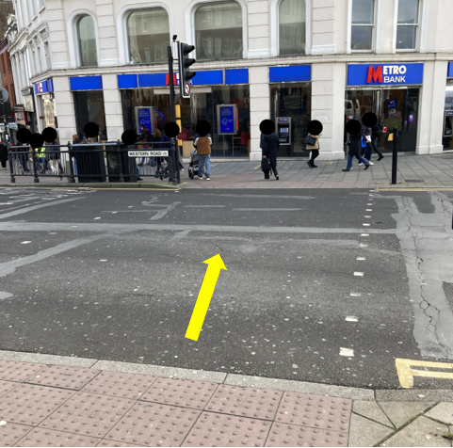
Turn left and facing the Clock Tower follow the pavement.
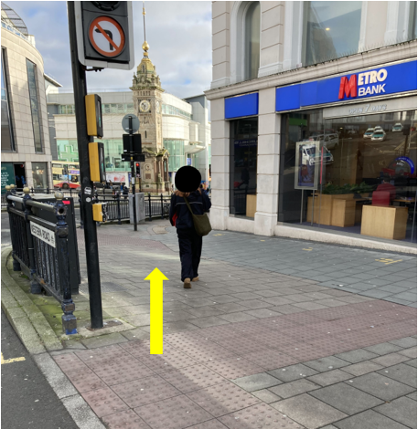

At the corner of Waterstones, turn right onto West Street.

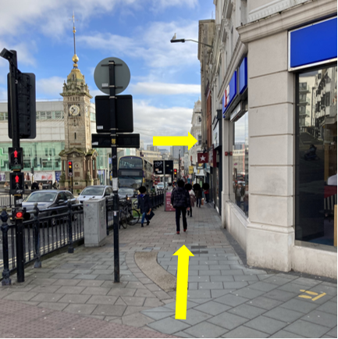
Continue down West Street.
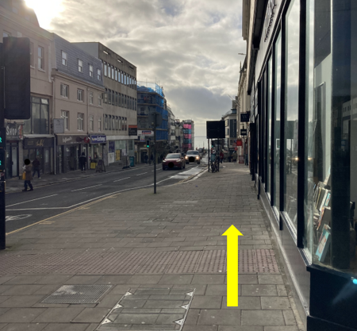
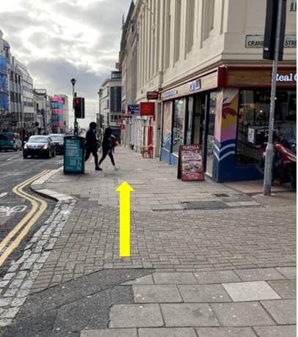
Take care when crossing towards Wetherspoons, this is an entrance to Churchill Square car park.

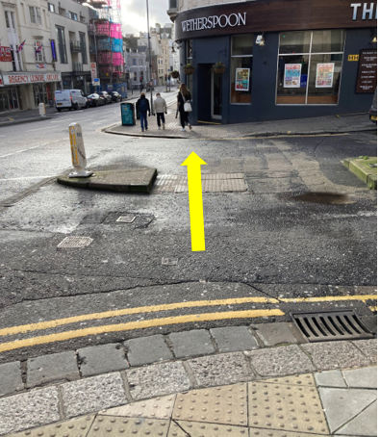

Continue down West Street.

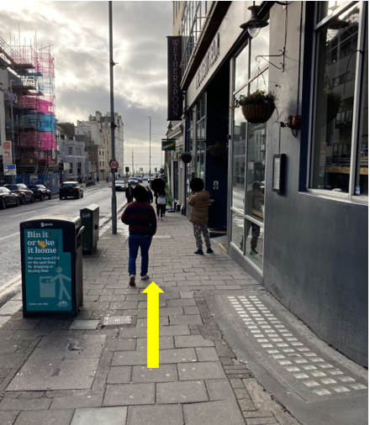
Turn right onto Russell Road.

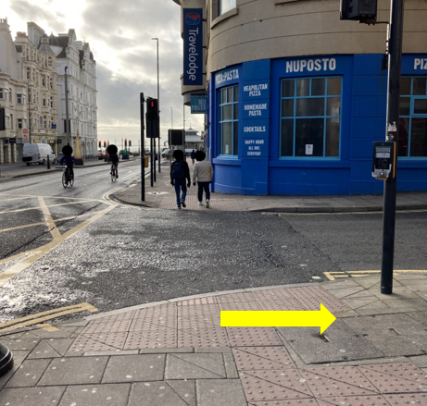

Continue along Russell Road towards the traffic lights.

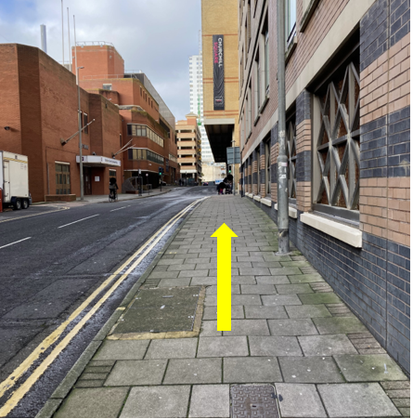
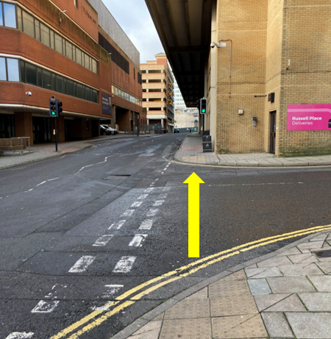

At the traffic lights cross over towards the rear entrance of the Brighton Centre.

