**Churchill Square bus stop (M&S side) to Kings Road – front entrance of the Brighton Centre**

**Distance 0.4 mile, approx. 7 minutes**

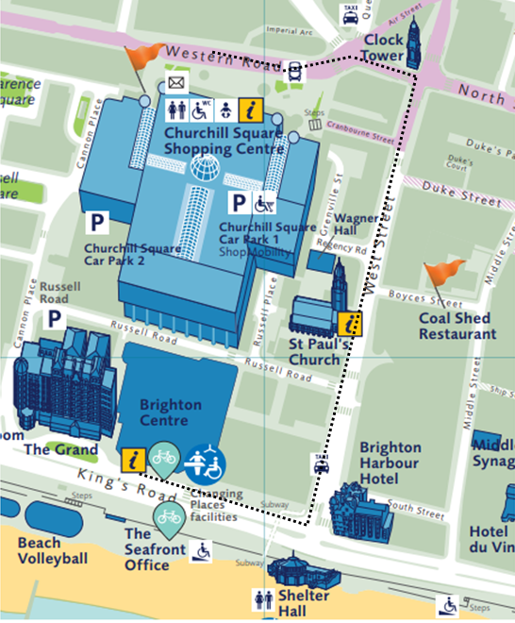

|  |
| --- |
| **From the bus stops on Western Road, outside or near the Marks & Spencer store, with the store to your left, go straight ahead towards a set of traffic lights.** |
|  |
|  |
|  |

|  |
| --- |
| **At the traffic lights, cross over towards the Metro Bank.** |
|  |
| **Turn left and facing the Clock Tower follow the pavement.** |
|  |
|  |

|  |
| --- |
| **At the corner of Waterstones, turn right onto West Street.** |
|  |
| **Continue down West Street.** |
|  |
|  |
| **Take care when crossing towards Wetherspoons, this is an entrance to Churchill Square car park.** |
|  |

|  |  |  |  |  |  |  |  |  |  |  |  |  |  |  |  |
| --- | --- | --- | --- | --- | --- | --- | --- | --- | --- | --- | --- | --- | --- | --- | --- |
| |  | | --- | | **Continue down West Street.** | |  | | **Cross over at the traffic lights and continue straight ahead towards the sea.**   | |  | |  | | **At the bottom of West Street, turn right onto Kings Road.** | |  | |  |  |  | | --- | | **Follow the path towards the Brighton Centre.** | |  | | **Continue along the front of the Brighton Centre.** | |  | |  |  |  | | --- | | **Front entrance to the Brighton Centre.** | |  | |
|  |